Economic Development
Invicta House
County Hall
Maidstone
Kent ME14 1XX
E-mail: allison.campbell-smith@kent.gov.uk

Direct dial | 03000 417040
Ask For: | Allison Campbell-Smith
Date: | Oct 24

Kent Ambassadors Briefing – Networking Briefing

I would like to invite you to an Ambassadors briefing on the 10th December 2024 at Darwin College, University of Kent, Canterbury, Kent, CT2 7NZ

The evening will start at 6.30pm with a drink’s reception and networking. We are aiming for the evening to end by 10pm.

The event is to enable Ambassadors to network with each other and to have a Leaders round up. Please see the attached agenda for timings.

As this is our December briefing it has been agreed as in previous years to open the invitation to partners. There will be a cost of £40.00 per head inclusive of VAT if you would like to bring your partner. Please send a payment to the bank details on the attached and indicate this on your reply form. Ambassadors do not need to pay for themselves.

The dress code for the evening will be lounge suits.

Parking instructions will be sent out to those that accept.

I would be grateful if you could let Allison have your availability by at allison.campbell-smith@kent.gov.uk by 18th October, to enable arrangements to be made.

Yours sincerely
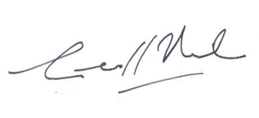
Geoff Miles
Chairman, Kent Ambassadors

