KENT AMBASSADORS’ CREATIVE INDUSTRIES BRIEFING
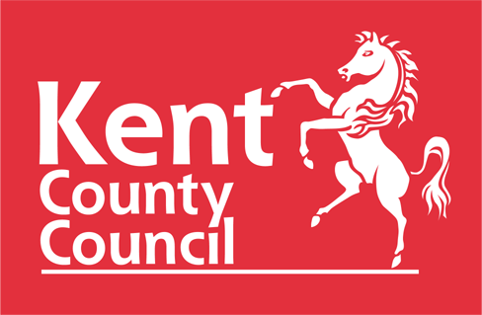
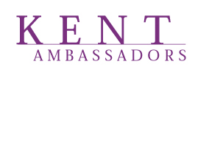

TURNER CONTEMPORARY
Rendezvous, Margate CT9 1HG

19 MARCH 2024

5.30 – 6.30 Optional Tour of the Turner Contemporary building

6.30 – 7.00 Drinks Reception.

7.00 – 7.05 Introduction and Opening Remarks by Geoff Miles, Chairman, Kent Ambassadors

7.05 – 7.20 Sarah Dance, Strategic Consultant, Sarah Dance Associates

Creativity, the creative industries and why bother?

7.20 – 7.35 Jo Nolan, Managing Director, Screen South

Overview of the Film and Creative Digital Sector in Kent

7.35 – 7.45 Q&A for Sarah and Jo

7.45 – 8.40 Main Course and discussion

8.40 – 8.55 Clarrie Wallis, Director, Turner Contemporary

Turner Contemporary and the burgeoning creative and arts scene in Margate

8.55 – 9.25 Dessert, coffee and discussion

9.25 – 9.40 ‘Leader’s Roundup’
Roger Gough, Leader, Kent County Council

9.40 – 9.55 Questions and Answers for Clarrie and Roger chaired by Geoff Miles

  - Closing Remarks by Geoff Miles

10.00 Close

