KENT AMBASSADORS’ JUSTICE BRIEFING
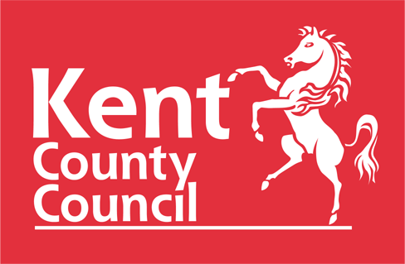


SHEPHERD NEAME

24th SEPTEMBER 2024

5.30 – 6.30 Optional Tour of the Brewery. This will leave from the Brewery Store.

6.30 – 7.00 Drinks Reception in the bar area of the Brewery Store.

7.00 – 7.05 Introduction and Opening Remarks by Geoff Miles, Chairman, Kent Ambassadors

7.05 Geoff to introduce Her Honour Adele Williams DL, a retired circuit judge

7.05 – 7.20 Her Honour Adele Williams DL, a retired circuit judge

Life in the Crown Court before and after covid.

7.20 – 7.35 Mark Icke, Prison Governor and Vice President of the Prison Governors Association.

Leadership and Criminal Justice career Journey

7.35 – 7.45 Q&A for Adele and Mark

7.45 – 8.40 Main Course and discussion.

8.40 – 8.55 Siobhan Draper JP, Diversity and Community Relations Magistrate: South East

Being a Magistrate

8.55 – 9.25 Dessert, coffee and discussion

9.25 – 9.40 ‘Leader’s Roundup’
Roger Gough, Leader, Kent County Council

9.40 – 9.55 Q&A for Roger and Siobhan

  - Closing Remarks by Geoff Miles

10.00 Close

