KENT AMBASSADORS’ GEOPARK BRIEFING
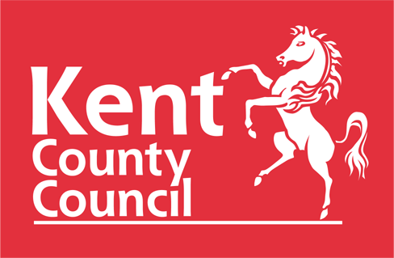


THE PINES CAYLX
Beach Rd, St Margarets Bay, Dover CT15 6DZ

16 APRIL 2024

2.00pm Welcome, tea coffee

2.15pm Presentation: The journey to securing a UNESCO Cross Channel Global Geopark in Kent and the Pas de Calais

2.45pm Q & A.

3.00pm Tea, coffee and informal discussions/ networking

3.20pm Informal walk to the cliffs to further discuss the Geopark proposal

5.00pm Return to venue and depart

