SHEPHERD NEAME BREWERY

Directions for visitor arriving by road and map of car parks
(Other info at www.swale.gov.uk.cp-faversham/)

- Take the M2 and exit at Junction 6
- Head towards Faversham - along Ashford Road
- Turn left at the junction and then immediately right into The Mall
- The road will bear round to the left and then right, then under a railway bridge
- Road bears round to the right and you will pass Faversham Railway Station
- Turn left into Newton Road and follow road down to the traffic lights
- Travel straight across at the lights and pass Tesco supermarket on your right. The Brewery is on your left, shortly after the zebra crossing. (The main entrance is painted white - 17 Court Street)
- The Visitor Centre is located within 11 Court Street, just within the pedestrianised area, on the corner of Court Street and Partridge Lane
- Public on-street parking at the front of the Brewery is strictly limited to a maximum of one hour until 10pm on Mondays to Saturdays
- To reach the Visitor Centre from the car park, walk up Partridge Lane and turn left into Court Street – the door to the Visitor Centre is the first on the left.
- COACHES – there are 2 council coach parking spaces on Church Street at Front Brents (ME13 7DH) on the other side of the creek if there is space but the main coach parking area after dropping off is at Macknade Fine Foods on Selling Road just off the main Canterbury Road (ME13 8XF)
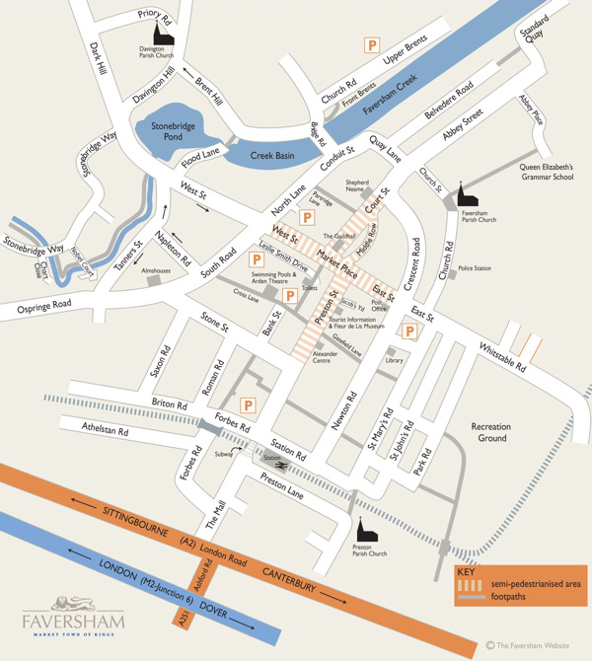
Partridge Lane:
55 Spaces
Max. Time: 12hrs
Queen’s Hall, Forbes Road:
140 Spaces
Max. Time: 12hrs

Central Car Park:
ME13 8PW or
ME13 7LE - 2 entrances
234 Spaces
Max. Time: 4hrs

Institute Road:
41 Spaces
Max. Time: 4hrs
Front Brents:
ME13 7DH
15 Spaces
Max. Time: Anytime
(There are 2 on-road coach parking spaces in Church Street)
Front Brents:
15 Spaces
Max. Time: Anytime

