The Pines Calyx is located within the Pines Garden on Beach Road.

**Reserved parking for the Calyx venue is located on 44 St Margaret’s Road, St Margaret’s Bay, Dover CT15 6EF** or roadside parking is available on Beach Road, St Margaret’s Bay, Dover, CT15 6DZ.

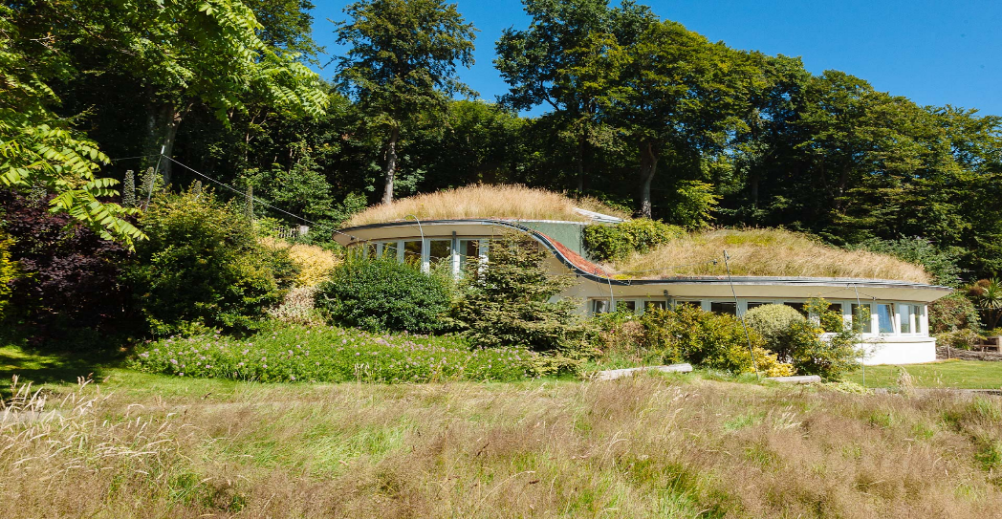

**Arrival and meeting point is:** Upper Roundel in the Pines Calyx from 1:30 PM.

**Local Directions**

From the A2, at the roundabout head along the A258 towards Deal.  You will pass the Swingate Inn on your right. Then take the next turning on your right, signposted St. Margaret’s at Cliffe.

Follow this rural road down for approximately 2 miles (you will pass a hotel called Wallett’s Court on your right-hand side) before coming to a junction. Turn right at the junction, taking you into the village of St. Margaret’s at Cliffe.  The road is called Sea Street.  Follow the road through the village, passing the shops. You will then pass the Church on your right shortly followed by the Primary School set back on your left.  At this point you will be driving uphill and at the top you should have a fantastic view out to sea.  Staying on the same road, follow the hill downwards towards the beach.  This is Bay Hill. The Pines Calyx is signposted at the top of the hill.  Once you have gone round the hairpin bend, you must take the next right onto Beach Road, again signposted Pines Calyx.  At this point there will be parking attendants visible to guide you to a parking space.  The Pines Garden main entrance is located on Beach Road, and the Pines Calyx is situated within the grounds.

**Roadmap Leading into St. Margaret’s**

**Village Map of St. Margaret’s**

**DIRECTIONS BY TRAIN**

Train Service – London / Ramsgate Line via Ashford

* Dover Priory (5.5 miles)
* Martin Mill (2 miles) is the next stop after Dover.

Useful search engine: [www.thetrailine.com](https://eur01.safelinks.protection.outlook.com/?url=http%3A%2F%2Fwww.thetrailine.com%2F&data=05%7C02%7CAllison.Campbell-Smith%40kent.gov.uk%7C734fd0f0c3f342272a1408dc28b2b270%7C3253a20dc7354bfea8b73e6ab37f5f90%7C0%7C0%7C638429995191980317%7CUnknown%7CTWFpbGZsb3d8eyJWIjoiMC4wLjAwMDAiLCJQIjoiV2luMzIiLCJBTiI6Ik1haWwiLCJXVCI6Mn0%3D%7C0%7C%7C%7C&sdata=DYrt0jtL0XOKCI%2FV5x5PVtVReg7pckpX5bXY21LfF2A%3D&reserved=0)

Buses

* 5 min walk from Dover Priory Station
* Stop A at the main bus station in Dover.
* No. 80A and 93 run to
* **St. Margaret’s Bay**
* **Stops at the top of the hill on the green**,
* short walk down the hill to the Pines Gardens and the Pines Calyx

Taxis

* Dover
* Taxis **01304 201 915**
* A2B Cars **01304 225 588**

**Please be aware that mobile phone signals are weak and predominantly French in St. Margaret’s Bay. If you make calls, you may be charged roaming charges as if you are in France!!!!**

Should you have any queries regarding local directions, please do not hesitate to contact the venue on 01304 851 737 or 01304 853 173.